2024 Arbor Day Seedlings Giveaway Information
Gila Monster Gambel Oak - Quercus gambelii 'Gila monster'
Height: 30’-40’ Spread: 20′-25′.
The story/seed source for the Gila Monster gambel oak comes from a mountain range west of Datil New Mexico near the Arizona border. The genetics of these gambel oaks lead to medium-sized single stem trees. The parent tree is found at a 7K foot elevation in an area that receives around 12" of annual precipitation and has endured several negative 30-degree days. The picture below is of the parent tree provided by Scott Scogerboe (Fort Collins Wholesale Propagator) and is the source of the seedlings. Zones 3-9.
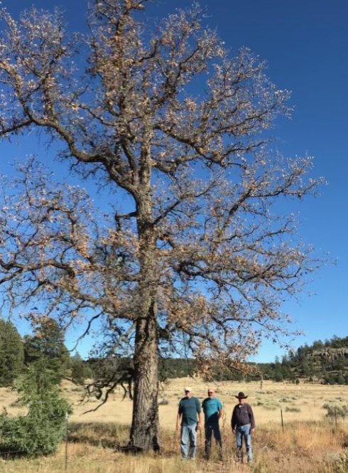
Chinkapin Oak – Quercus muehlenbergii
Height: 45’-55’ Spread: 30’-40’
A hard-wooded and sturdy oak that is proving to be a good shade tree for our area because it is tolerant of alkaline and poor condition soils. Attractive glossy leaves turn yellow to russet red in the fall. This is a drought/ heat tolerant shade tree that is well suited for Grand Junction’s climate and is an excellent shade provider to cool your yard during the summer heat. Zones 3-9.
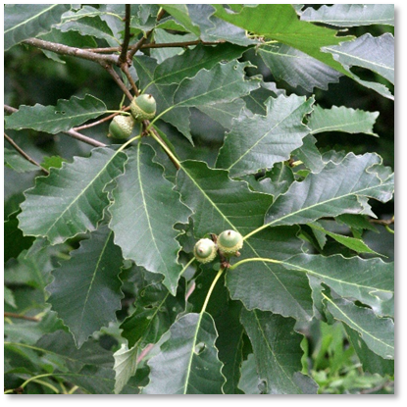

Northern Catalpa - Catalpa speciosa
Height: 40′-60′ Spread: 20′-40′
Northern catalpa is known for its beauty and utility. Catalpa's durable wood is often used for posts and railway ties. In the landscape, northern catalpa is very ornamental with large, attractive leaves, showy panicles of spring flowers, and decorative hanging pods in the winter. Northern catalpa is a tough, adaptable tree that tolerates urbanization. It enjoys full sun or partial shade and moist, deep, fertile soil. Catalpa tolerates drought and can withstand a variety of soils and moisture levels, including poor, dry, wet or compacted soils. It will also tolerate alkaline sites. Zone 4-8.
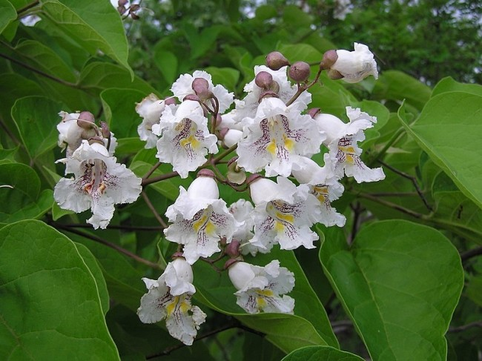
Chinese Bean Tree- Catalpa fargesii
Height: 30′-50′ Spread: 20′-35′
Catalpa fargesii f. duciouxii, sometimes commonly called Chinese bean tree, is a medium-sized, deciduous tree with an open rounded crown that is native to central China. This is a unique species of catalpa not commonly available to the public. It was discovered by westerners around 1900 and was subsequently named after French plant collector Pere Francois Ducloux. Large summer flower clusters ranging from white, to pink, to lilac in color. Tolerant of a wide range of soil conditions including both wet and dry soils. Full sun to partial shade. Zones 5-8.
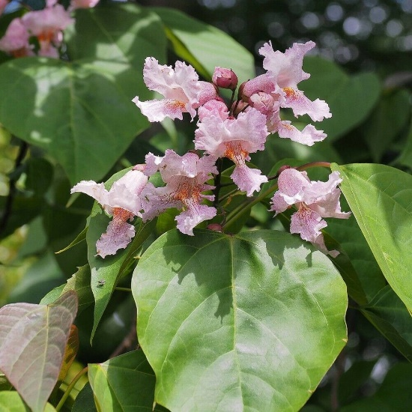
Shellbark Hickory – Carya laciniosa
Height: 50’-60’ Spread: 30’-40’.
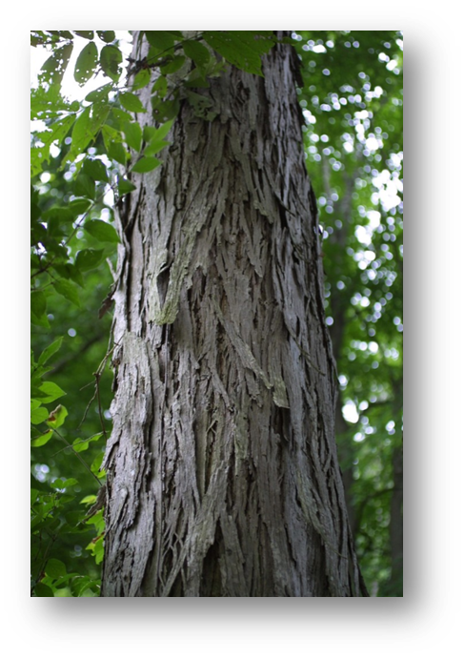
The Shellbark Hickory is a high-branching tree with a straight, slender trunk and a narrow, oblong crown. It's a sturdy tree with shaggy bark. The nuts are large and sweet. The tree will bear nuts in 10-12 years, although generally not heavily. One of a few tree species that forms a taproot and is a unique tree that develops a distinct plated bark. This is species is newer to Grand Junction and seedling success will be used as a measure to track potential in our area. Zones 4-8.

Kentucky Coffeetree- Gymnocladus dioica
Height: 60′-80′ Spread: 40′-55′
Kentucky coffeetree is a shade large tree with branches turning slightly outward to form a high, narrow, and irregularly rounded crown. The bark is dark gray or brown and will become deeply fissured as the tree matures. The coffeetree is tolerant of heat, drought, urban conditions, and is an excellent shade tree for Grand Junction. The name "coffeetree" comes from settlers using the seeds for a coffee substitute. Native Americans also used the roasted seeds for beverages and food.
Zones 3-8.
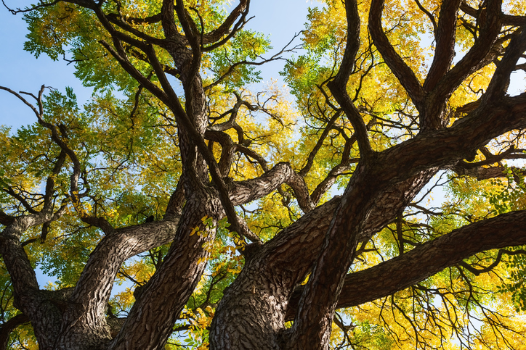
Ohio Buckeye - Aesculus glabra
Height: 45’- 50’ Spread: 30’-35’
Medium sized specimen that produces an eye-catching pale yellow/green flower spike in the spring that later turns into dark brown nut with pale scar encased in golden brown husk. The tree’s unique palmately compound leaves turn orange to yellow in the fall. Species prefers to be planted more protected sites and can perform better in areas with less direct winter sunshine. Zones 3-7.

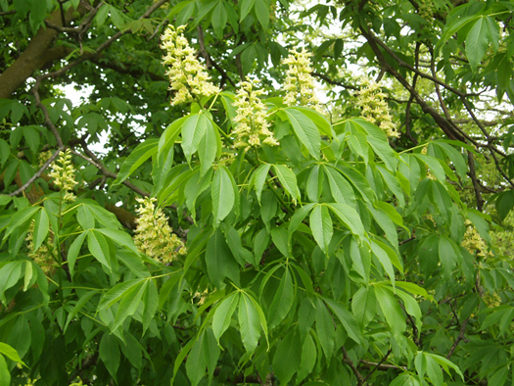
Texas Red Oak - Quercus buckleyi
Height: 50′-60′ Spread: 40′-50′.
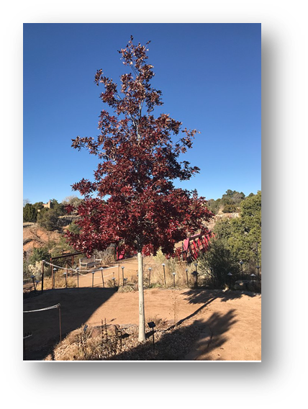
Texas Red is an excellent shade tree that has striking red fall color. An alkaline-tolerant member of the red oak group that is closely related to the Shumard Oak but will not grow as large. Grows in the alkaline regions of hot and dry west Texas. Full sun. Zones 5-9.

Bigtooth Maple - Acer grandidentaum
Height: 20′-25′ Spread: 15′-20′.
Colorado native that can be trained into a single-stem small tree or allowed to develop into a large multi-stem shrub. Tree produces small yellow flowers in spring that are followed by production of 1” long double-winged seeds. Slower growing ornamental with orange to red fall color. Zones 3-8.
