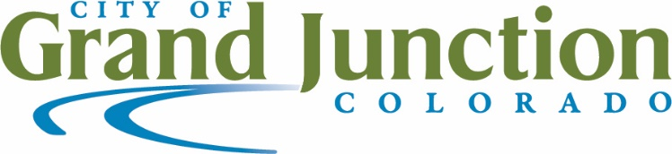

MEDIA RELEASE

For Immediate Release

Contact:

Sara Spaulding, APR

Communications & Engagement Director

970-244-1507

saras@gjcity.org

Grand Junction Softball Season Kicks off with a tournament march 11 & 12

Adult softball season registration deadline is March 27, 2023

GRAND JUNCTION, Colo. March 2, 2023 – The City of Grand Junction invites community members to “play ball” with a pre-season, double elimination tournament on Saturday and Sunday, March 11 and 12, 2023. The registration deadline for the tournament is March 8. The six-game spring season softball league begins the week of April 3 and the registration deadline is March 27.

Tournament and league play offer coed, men’s and women’s divisions. League games are held on Tuesdays, Wednesdays, Thursdays, or Sundays. Register online.

“Softball is the City’s largest adult athletic program with more than 200 adult softball teams consisting of 15 people on each team”, said Parks and Recreation director Ken Sherbenou. “The softball tournament and seasonal leagues offer adults in our community the opportunity to stay active, create new friendships, and engage in good natured competition.”

In addition to the spring league, Grand Junction Parks and Recreation also offers summer and fall adult softball leagues. New this year is one-pitch softball beginning in July. Additional information regarding these and other programs will be available in the summer activity guide distributed at the beginning of May. With the new LED lights meeting International Dark-Sky Association (IDA) standards, competition can continue later in the evening which means more teams can be accommodated in league play and for tournaments.

Parks and Recreation offers a wide variety of recreational programming for all ages and abilities. For questions regarding the pre-season softball tournament or spring softball league, contact Grand Junction Parks and Recreation by calling 970.254.3866, emailing gjparksandrec@gjcity.org, or visiting the office at 1340 Gunnison Avenue.

###

